FINANCE 20/30 MODULE 1: WHY MONEY MATTERS: EXPLORE THE VALUE OF MONEY
- Explore the concept that every money decision involves a trade-off and an OPPORTUNITY COST
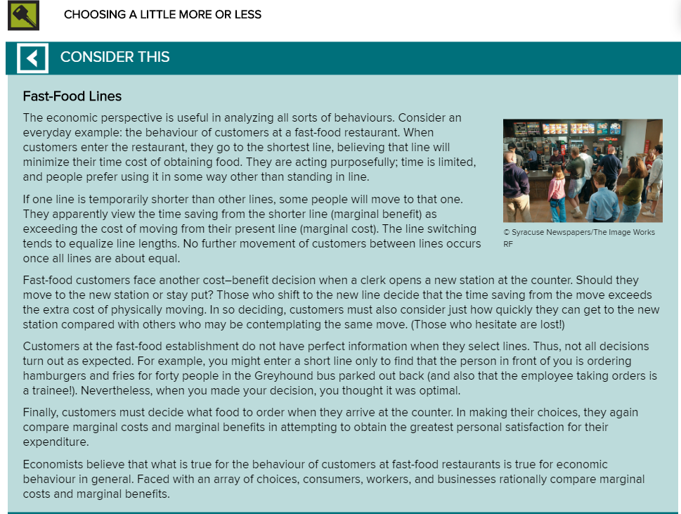
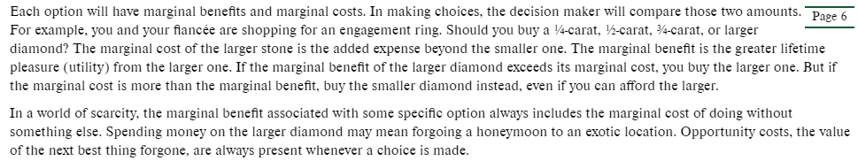

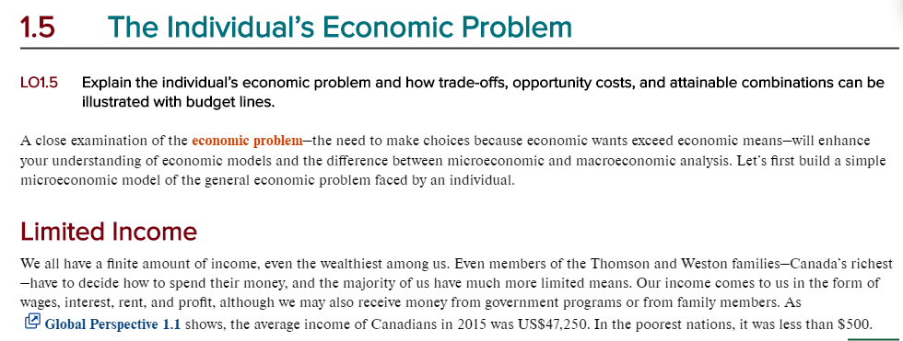
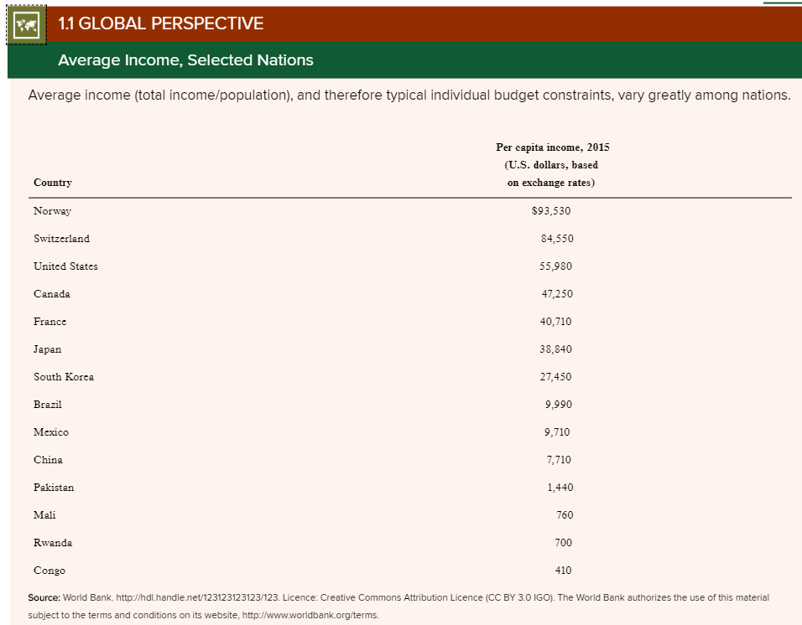

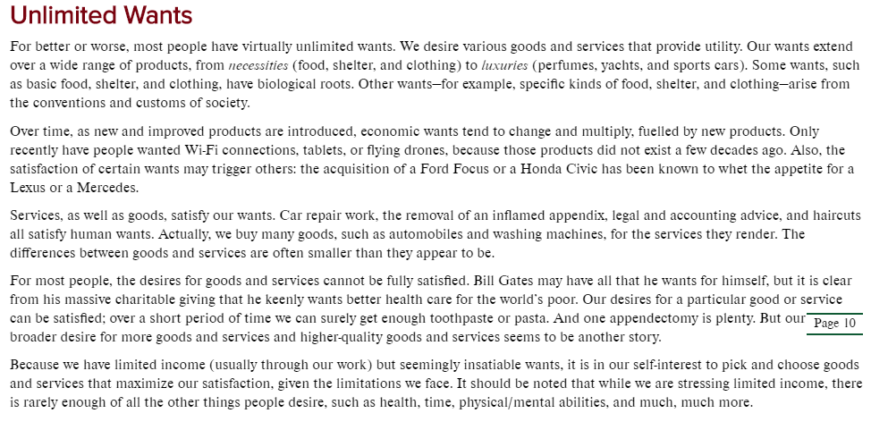

Opportunity Cost Assignment

For each of the scenarios below develop the equation, solve for what it asks and write a sentence that states what the opportunity cost would be.

- A farmer has a quarter of land. He can use this land to raise either 75 tonnes of wheat or 25 tonnes of lamb. What is the opportunity cost if the farmer was to use the land for lamb.

- Using the same numbers above. Calculate the opportunity cost if he wanted to know what the opportunity cost would be to raise 1 tonne of lamb.

- A creamery has one room in which they produce both cream and butter. In 3 hours they can produce 50 lbs of butter or 350 litres of cream. What is the opportunity cost if they produce the 350 litres of cream?

- What is the opportunity cost if they were to produce 1lb of butter?

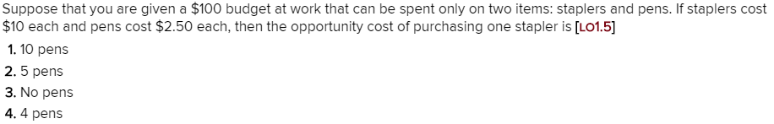

6.

7.
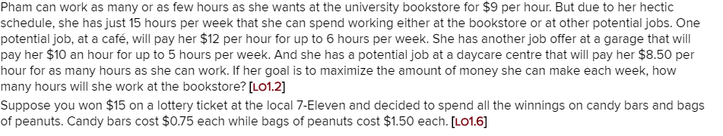

8.

